Laboratory Exterior Door Sign- Training Required to Enter

This is a working laboratory.  Safety glasses are required to enter.  All persons entering must have safety training appropriate for the hazards listed below: |  |  |   Safety Glasses Required
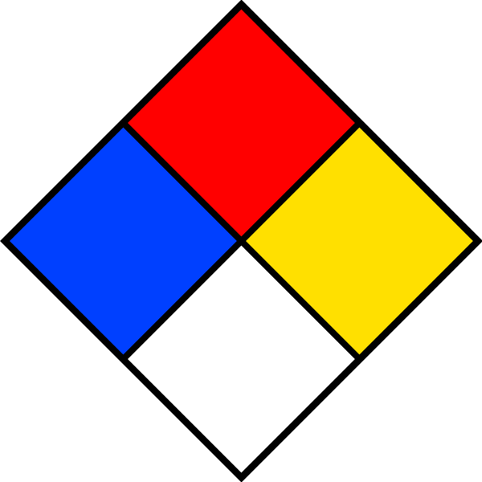  Chemical Hazards | 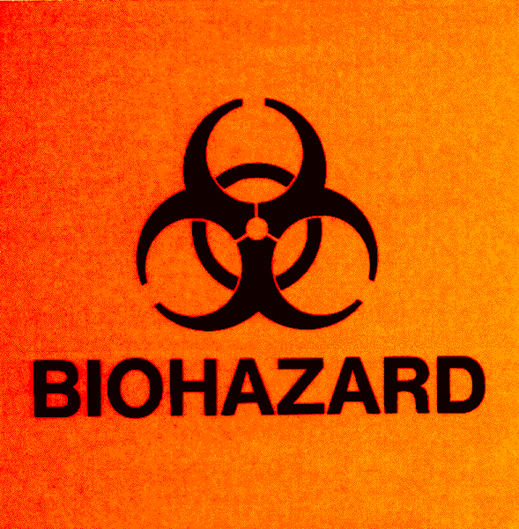  Biological Hazards | 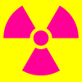  Radiation Hazards | 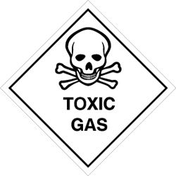  Toxic Gas Hazards
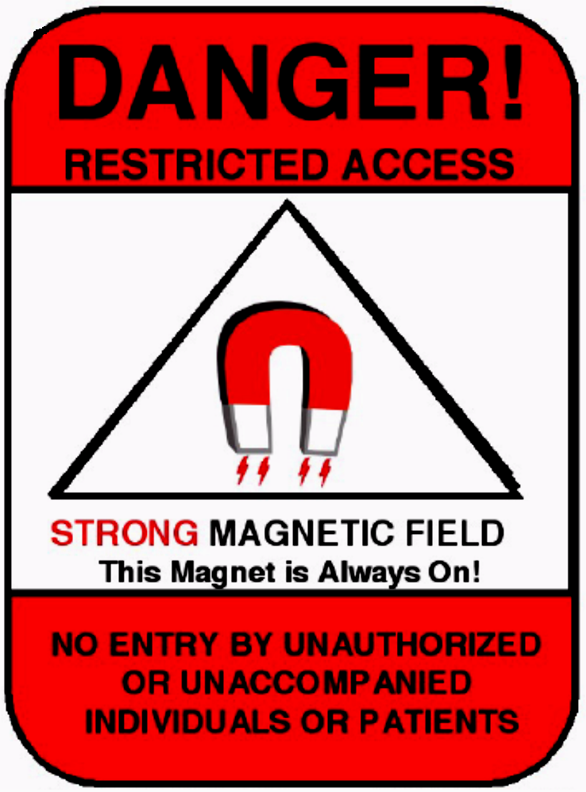  Strong Magnetic Field | 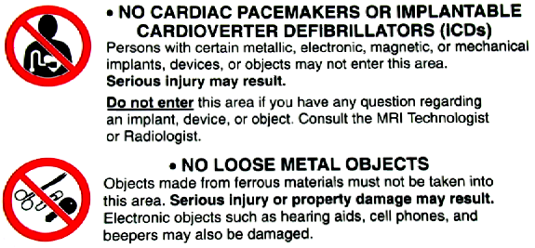  No Cardiac Pacemakers or Ferro-Metallic Medical Implants | No Loose Metal Objects |  | 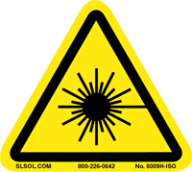  Laser Hazards
If you have questions regarding these requirements, please contact Georgia Tech Environmental Health and Safety at 404-894-4635.

Laser warning signs (ANSI compliant) must be posted at all Class 3B and 4 laser work areas. Contact the Laser Safety Officer at laser@gatech.edu for assistance.

Radiation warning signs must be posted at all radioactive material and x-ray work areas. Contact the Office of Radiological Safety at ors@ors.gatech.edu for assistance.
All open lab areas such as in the Whitaker Building (BME), the Petit Institute for Biology and Biosciences Building (IBB), or the Engineered Biosystems Building (EBB) must be prominently posted with room number and PI name/emergency contact information in the lab to distinguish it from the adjacent labs.

